Experiments

S.NO. | Objective | Page No.
1. | Explain Structural Models.
2. | Explain Framework Models.
3. | Explain Dynamic Models.
4. | Explain Process Models.
5. | Explain Cost Benefit Analysis Method (CBAM).
6. | Explain Architecture Tradeoff Analysis Method.
7. | Explain Attribute Driven Design method (ADD).
8. | Explain UML.
9. | Explain Call and Return Architecture.
10. | Data Centered Architecture.

1. Structural Models
Overview
Structural models describe the static organization and structure of a software system. They depict how system components are organized, their relationships, and how they interact with each other at a high level.
Key Characteristics:
- Focuses on components and their interactions
- Shows data flow and component dependencies
- Used during analysis and design phases
- Represents the building blocks of the system
Example:
Consider an e-commerce system with the following structural components:
- User Interface Layer
- Business Logic Layer
- Data Access Layer
- Database
Each layer represents a structural component, and the arrows show dependencies and communication between them.
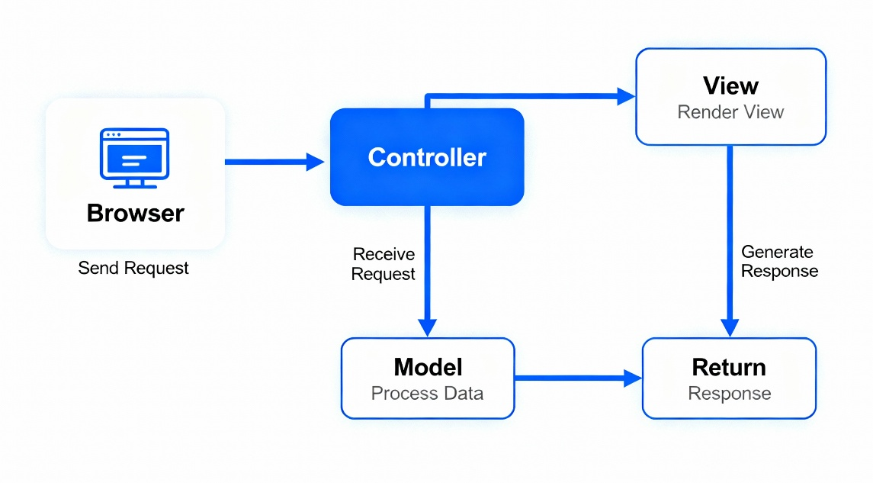
Figure 1: Structural Model Example showing system components and their relationships

2. Framework Models
Overview
Framework models define reusable architectures and design patterns that provide a foundation for building software applications. They establish a standardized approach to solving recurring design problems.
Key Characteristics:
- Provide pre-built solutions to common problems
- Promote code reusability and consistency
- Include predefined classes and components
- Enforce architectural patterns like MVC, MVVM
Common Frameworks:
- MVC (Model-View-Controller): Separates application into Model (data), View (presentation), and Controller (business logic)
- MVVM (Model-View-ViewModel): Used primarily in UI development
- Microservices Framework: Decomposes application into independent services
Example:
A web framework like Spring follows the MVC pattern:
- Model: Database entities and business objects
- View: JSP or HTML templates
- Controller: Request handlers that process user input
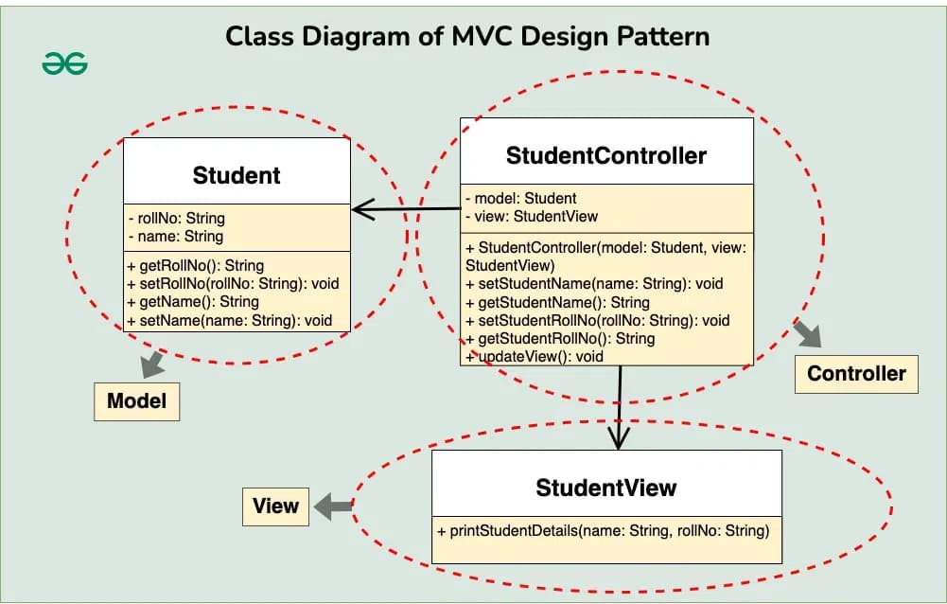
Figure 2: MVC Framework Model showing separation of concerns

3. Dynamic Models
Overview
Dynamic models describe how systems behave over time and capture the temporal aspects of a system. They show the sequence of events and state changes that occur during system execution.
Key Characteristics:
- Focuses on system behavior and state changes
- Captures interactions between objects over time
- Shows control flow and event sequences
- Used for validation and testing
- Represented through state diagrams and sequence diagrams
Example:
Consider an online order system:
- Initial State: Order Created
- Event: Payment Verification
- State: Order Confirmed
- Event: Item Shipped
- Final State: Order Delivered
At each state, the system responds to different events, transitioning to new states.
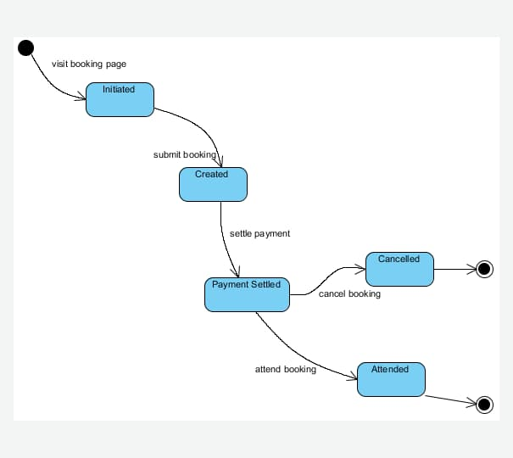
Figure 3: Dynamic Model showing state transitions and behavioral sequences

4. Process Models
Overview
Process models define the sequence of activities, phases, and steps involved in software development from initial conception to deployment and maintenance. They provide a structured approach to managing the development lifecycle.
Common Process Models:
Waterfall Model:
- Sequential phases: Requirements → Design → Implementation → Testing → Deployment
- Each phase must be completed before the next begins
- Well-suited for projects with clear, stable requirements
Incremental Model:
- Divides development into smaller increments
- Each increment adds functionality
- Faster feedback and delivery
Spiral Model:
- Combines waterfall and iterative approaches
- Emphasizes risk management
- Multiple cycles (spirals) of planning, risk analysis, development, and evaluation
Example:
A project using Waterfall Model:
- Requirements Phase: Document all system requirements
- Design Phase: Create system architecture and module designs
- Implementation Phase: Code all modules
- Testing Phase: Test functionality and fix bugs
- Deployment: Release to production
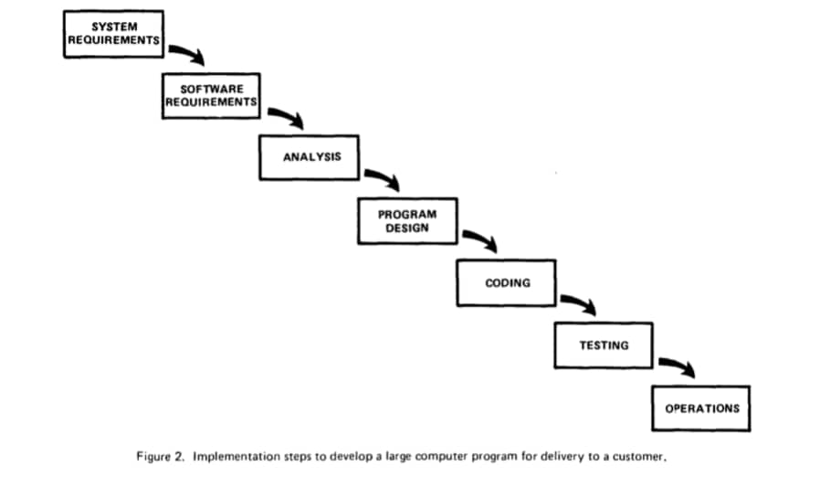
Figure 4: Process Model - Waterfall showing sequential development phases

5. Cost-Benefit Analysis Method (CBAM)
Overview
CBAM is an economic analysis method that helps stakeholders evaluate and choose among different architectural alternatives for system design and maintenance by calculating the return on investment (ROI) for each strategy.
Purpose:
- Quantifies costs and benefits of architectural decisions
- Compares different architectural strategies
- Determines ROI for each strategy
- Supports decision-making with economic data
CBAM Process Steps:
- Choose Scenarios and Architectural Strategies: Identify the quality attributes and design strategies to evaluate
- Assess Quality Attribute Benefits: Determine how each strategy impacts quality requirements
- Quantify Benefits: Assign numerical values to the benefits of each strategy
- Quantify Costs and Schedule: Calculate the implementation costs and time requirements
- Calculate Desirability: Compute the ROI and expected value of each option
- Make Decisions: Select the strategy with the best ROI
Example:
An application needs improvement in performance. Two strategies are proposed:
- Strategy A: Hardware upgrade (Cost: $50,000, Benefit: 30% improvement, ROI: 1.8)
- Strategy B: Code optimization (Cost: $20,000, Benefit: 20% improvement, ROI: 3.2)
CBAM analysis would recommend Strategy B due to higher ROI despite lower absolute benefit.
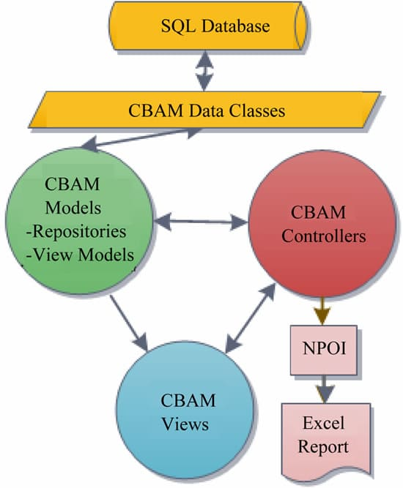
Figure 5: CBAM Process - Cost-Benefit Analysis Method workflow

6. Architecture Tradeoff Analysis Method (ATAM)
Overview
ATAM is a structured, scenario-based approach for evaluating software architectures relative to quality attribute goals. It identifies risks, sensitivities, and tradeoffs associated with architectural decisions.
Key Objectives:
- Evaluate architecture against quality attributes
- Identify architectural risks and non-risks
- Document sensitivity and tradeoff points
- Facilitate stakeholder communication
ATAM Process (9 Steps):
- Present the method and business drivers
- Describe the architecture
- Identify architectural approaches
- Generate quality attribute utility tree
- Analyze architectural approaches
- Brainstorm and prioritize scenarios
- Reanalyze architectural approaches
- Present results and prioritize scenarios
- Document risks and tradeoff points
Key Concept - Quality Attribute Utility Tree:
Hierarchical representation of quality requirements:
- Top Level: Quality attributes (Performance, Security, Modifiability)
- Middle Level: Refinements (Latency, Access Control, Code Changeability)
- Bottom Level: Concrete scenarios
Example:
For a financial system, quality attributes might be:
- Security: Data encryption, access control
- Performance: Transaction processing speed (< 2 seconds)
- Availability: System uptime (99.99%)
ATAM analyzes tradeoffs: Increasing security may decrease performance; high availability may increase costs.
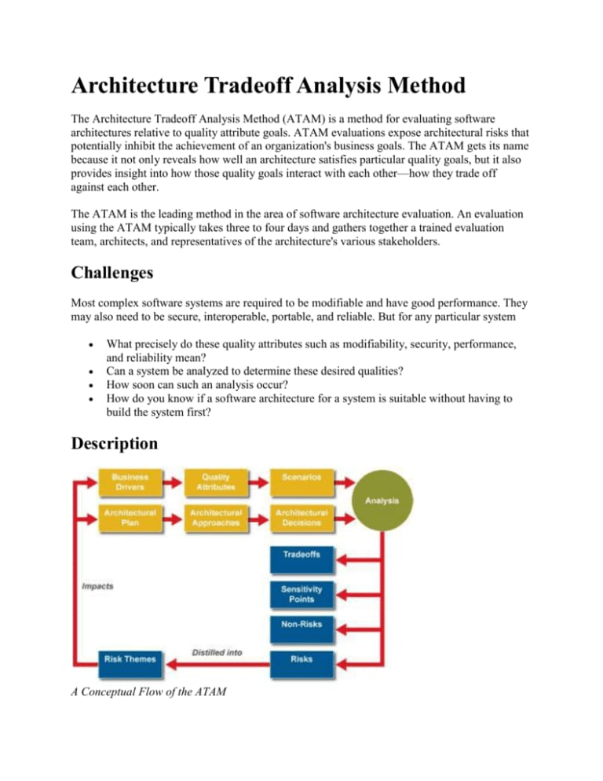
Figure 6: ATAM - Architecture Tradeoff Analysis Method showing quality attributes and analysis process

7. Attribute-Driven Design (ADD) Method
Overview
ADD is a systematic method for designing software architecture based on quality attribute requirements. It guides architects in making design decisions that satisfy both functional and quality requirements through iterative decomposition.
Core Principle:
Design decisions are driven by quality attributes (performance, security, modifiability) rather than functional requirements alone.
ADD Process (Key Steps):
- Confirm Requirements Information: Ensure sufficient requirements documentation
- Choose System Element to Decompose: Start with overall system or highest priority component
- Identify Architectural Drivers: Determine the most important quality attributes for this element
- Choose Design Concept: Select patterns and tactics that satisfy the drivers
- Instantiate Architectural Elements: Create components, connectors, and their relationships
- Define Interfaces: Specify how elements communicate
- Verify and Refine: Check that the design satisfies quality attributes
- Decompose Recursively: Apply ADD to each new element until the design is complete
Example:
For a mobile banking application:
- Architectural Drivers: Performance (response time < 500ms), Security (encryption), Usability
- Design Concept: Client-server architecture with local caching
- Decomposition: Separate UI components, business logic, and data access layers

8. Unified Modeling Language (UML)
Overview
UML is a standardized visual notation for modeling software systems. It provides a comprehensive set of diagrams to represent structure, behavior, and interactions in object-oriented design.
UML Diagram Categories:
Structural Diagrams (Static View):
- Class Diagram: Shows classes, attributes, methods, and relationships
- Component Diagram: Represents physical components and dependencies
- Deployment Diagram: Shows system deployment configuration
- Package Diagram: Organizes model elements into packages
Behavioral Diagrams (Dynamic View):
- Use Case Diagram: Shows actors and use cases
- Sequence Diagram: Shows object interactions over time
- Collaboration Diagram: Shows interactions and object relationships
- State Machine Diagram: Shows states and transitions
- Activity Diagram: Shows workflow and processes
Benefits of UML:
- Standardized notation understood by all stakeholders
- Supports communication across teams
- Documents design decisions
- Aids in validation and verification
Example:
E-commerce system UML diagrams:
- Class Diagram: Product, Customer, Order, Payment classes and their relationships
- Use Case Diagram: Customer purchase flow, Admin product management
- Sequence Diagram: Order processing sequence showing interactions between objects
- State Diagram: Order state transitions (New → Processing → Shipped → Delivered)

9. Call and Return Architecture
Overview
Call and Return architecture, also known as the Main-Subroutine architecture, is one of the most traditional and dominant architectural styles. It decomposes a system into a hierarchy of components that communicate through explicit calls and returns.
Key Characteristics:
- Hierarchical decomposition
- Components are programs/functions/methods
- Explicit call-return communication pattern
- Follows subroutine/procedure paradigm
- Single thread of control (in basic form)
Main Styles:
1. Main Program and Subroutines:
- One main program controls the flow
- Other components are subroutines called by main
- Results returned to caller
- Simple and straightforward
2. Layered Style:
- Components organized into layers
- Each layer provides services to layers above
- Layers only call adjacent lower layers
- Creates clear separation of concerns
Advantages:
- Easy to understand and implement
- Good for decomposing problems hierarchically
- Clear control flow
- Natural fit for functional programming
Disadvantages:
- Tight coupling between caller and called components
- Difficult to modify components
- Limited scalability
- Not suitable for concurrent systems
Example:
A compilation system using call and return:
Main Program
├─ Scanner (reads source code)
├─ Parser (syntax analysis)
├─ Semantic Analyzer (meaning analysis)
├─ Code Generator (produces output)
└─ Symbol Table Manager (shared utility)
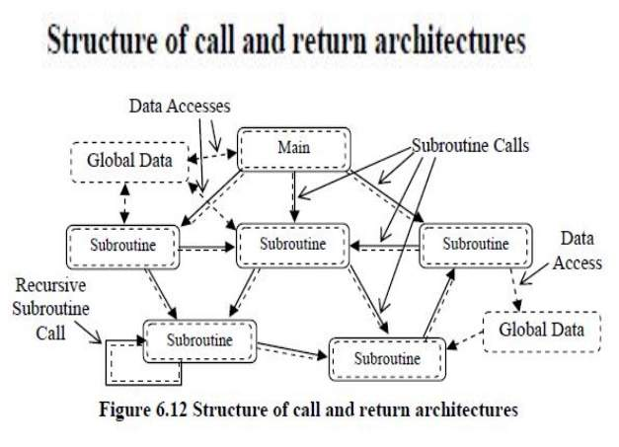
Figure 9: Call and Return Architecture showing hierarchical component organization

10. Data-Centered Architecture
Overview
Data-Centered architecture emphasizes shared data repositories as the primary means of communication between system components. All components interact through a central data store rather than direct component-to-component communication.
Key Characteristics:
- Central data repository or database
- Independent components operate on shared data
- Components communicate only through data store
- Implicit invocation (triggered by data changes)
- Data consistency is critical
Main Styles:
1. Repository Architecture:
- Central database stores all shared data
- Components access and modify data in repository
- Components operate independently
- Suitable for data-intensive applications
2. Blackboard Architecture:
- Central data structure (blackboard) holds solution state
- Processes are triggered by blackboard changes
- Components update blackboard with partial solutions
- Used for AI and complex problem-solving
Advantages:
- Efficient data sharing
- Components are loosely coupled
- Scalable for large data volumes
- Good for data-centric applications
- Easy to add new components
Disadvantages:
- Data store becomes single point of failure
- Performance bottlenecks at data repository
- Complexity in managing data consistency
- Privacy concerns with centralized data
Example - Repository Style:
A medical records system:
- Central Repository: Patient database
- Components: Doctor interface, Lab results processor, Pharmacy system, Billing system
- All components read/write to patient database
- Components don't communicate directly
Example - Blackboard Style:
A speech recognition system:
- Blackboard: Partial recognition hypotheses
- Components: Acoustic processor, Language model processor, Context processor
- Each component adds suggestions to blackboard
- Best recognition emerges from collaboration
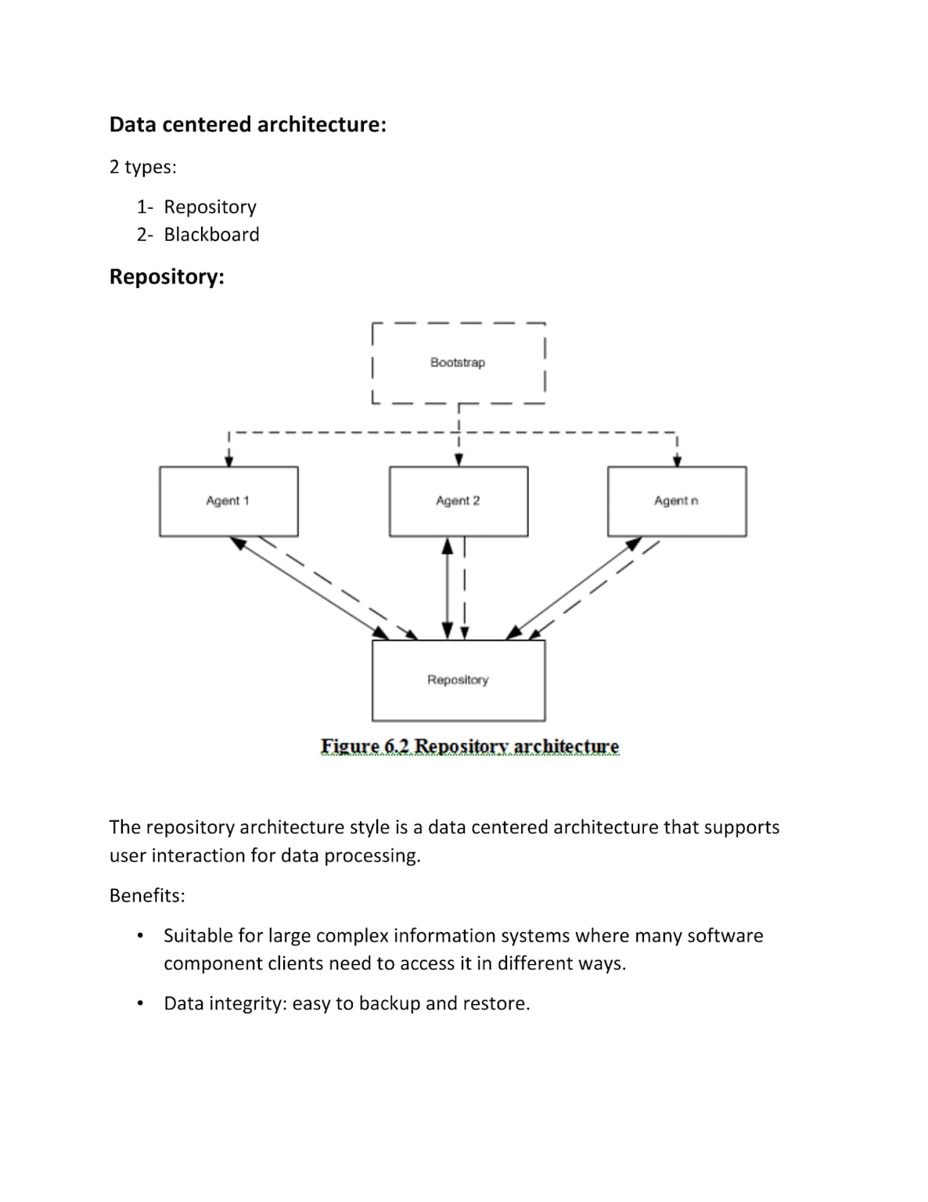
Figure 10: Data-Centered Architecture showing repository and blackboard styles

